SCHOOL OF ARCHITECTURE, BUILDING AND DESIGN
FOUNDATION IN NATURAL BUILD ENVIRONMENT

PRESENTATION TITLE: Hair Salon
GROUP MEMBERS:
Names | Roles during Presentation
Lim Xiu Qing | Editing Videos and appendix
Tan Vin Nie | Bio of Swiss, Klang, Selangor and comparative analysis of Swiss
Vivian Tay Huey Shuen | Recommendation
Yeoh Sin Yuen | Bio of P & L Hair Salon, Seremban, Negeri Sembilan
Ho Zi Yan | Comparative analysis of P & L Hair Salon
Yong Ai Yi | Reference and presentation slides
Wong Cho Mun | Summary and history of trades/business

ENGLISH 1 (ELG 30505)
ASSIGNMENT 2: ORAL PRESENTATION
LECTURER:
SUBMISSION DATE: 15 Jan 2016
PRESENTATION DATE: 22 Jan 2015
No. | TITLE | Page Number
1 | Key Summary | 3
2 | History of the trade/business | 4-5
3 | Description of Businesses | 6-8
4 | Comparative Analysis | 9-16
5 | Recommendation | 17-18
6 | Bibliography | 19
7 | Appendices | 20-27
8 | References | 28

Key Summary

We have done our research on two similar businesses, which are hair salon. One of the hair salon that we have chosen are Swiss, which is located at Klang, Selangor. We have interviewed the owner of Swiss, Kelly. From the interview, we get to know how Kelly operates and runs the business so successfully. The other hair salon we chose is P & L hair salon, located at Seremban, Negeri Sembilan. We have interviewed the two owners which are operated by husband and wife partnership. They found this business without any workers. We feel proud with their insistences and confidences. We have learned how some obstacles affect their business as well as how they face and solve the problems. Between these two businesses, we found that there are major contrast on how they manage to run and maintain a business.
Before going for an interview, we have to call to their shops in order to make an appointment with him or her. We have prepared approximately 20 questions in order to help us to collect and gather the information about the businesses. After we have done the interview, we start to do our reports using the information and knowledge we have learned from the visit.
Hair Salon seems like a very simple and easy business, but it requires a lot of time to improve and maintain the skill and technique of barbering. To retain the customers, owner has to find the ways to fight against the competitors in the competitive market nowadays.

History of the trade/business

Hair is the most easily changed physical feature of the human body. Nowadays, people usually visit hair salon shops or barber shops few times a month to have some services such as cutting, coloring, straightening, and permanent waving. Hair salons also sell hair-care products, which is used for hair treatment. The process of cutting, cleaning, coloring, styling, and arranging hair are known collectively as hairdressing. When the practice of hairdressing relates specifically to men, which includes the service of grooming beards and mustaches, it is known as barbering.
Different countries have different kind of stories about hairdressing. In ancient Egypt, wealthy men and women would have shoulder-length hair or hair cut short to the nape or even clean shaven heads. However a shaven head was worn by young adults before they become of age, they would leave a small curl in the side of their head, named ’Lock of Youth’, to symbolize their age. Young girls wore plaits, braids or sometimes ponytails.

In ancient Greece and Rome, wealthy men had their servants as personal hairdressers, in addition to dyeing and shaving. Simple hairstyles would consist for women wearing their hair down and confining it from the face by using a band circling the head. Young girls wore a simple bun at the base of the neck. In Ancient Rome hairstyles became an expression of a person’s identity as much as it is today and again the style determined the person’s wealth, status, gender and age. For women, their hair indicated how attractive and wealthy she was.

At the end of the 1800s, the transition from barber shops to salons are all over the world. However, women were still styling their hair by their servants. Salons started advertising in a big way to get women out of their homes. Around this time, a self-made entrepreneur Martha Matilda Harper opened the first public salon called ‘The Harper Hair Parlor’. She invented the salon recliner chair, but never patented her invention. She started training schools and employed the girls in her salon.
From the 19th centuries to 20th centuries, the demand of hairdressing have been increased doubly in every year. Beauty salons became the go-to-place for women to escape from their mundane lives. All people, no wonder the ages and gender, need to visit the salon and barber shops every month to have your hair cut. The business of hairdressing became popularized among the society.
The hairdressing industry in Malaysia is gaining popularity amongst the younger generations. An increase in the establishment of hair salons in Malaysia has made the market in the hairdressing industry much more competitive. To gain high profits, the price of services such as colouring, bleaching and rebonding cost a lot, ranging from hundreds to thousands and above. It can be concluded that, nowadays, the youths in Malaysia are willing to spend vast amounts of money for their hair, making the hairdressing industry increasingly popular.

Brief Description of the Businesses
Swiss
Swiss is a hair salon located at Klang, Selangor. We were honored to interview the shop’s owner, Kelly to find out more about her business. Kelly has enjoyed handwork for approximately 10 years after her high school graduation. She worked as an apprentice before she really acquired the skills and techniques of hairdressing. When she first touched this handwork, she immediately discovered her love and passion towards hairdressing. After that, she worked for about 8 years before having her own hair salon.
Swiss started at the year of 2001 in one of the shop at Klang. She then expanded her business to another branch which was just behind her first-founded shop. She had employed 6 apprentices to help her running the business. To retain the customer, they have to reach the customers’ expectations and standards in order to give them a suitable and fashion hairstyle. Fashion trends come and go. Therefore, they have to improve their skills of hairdressing by learning the different hairstyles to content the customers. They maintain a friendly, fair, and creative work environment, which respects a diversity in ideas as well as the encouragement of hard work. Services that Swiss provides include haircuts, hair washing, hair coloring and scalp treatment. Other than that, Swiss also provides booking services due to the fact that they only have one stylist on duty.
Their customers are in variety of ages. Most of the customers are white collars, who have the ability to spend their money on hairdressing. They spend much on coloring, straightening and waving which cost more than RM100, such as RM200++ for straightening our hair. Kelly stated that their hair salon normally has 20 customers for each consecutive day. They have to develop a good relationship with the customers as well in order to retain the customers and capture their attention for their abilities.
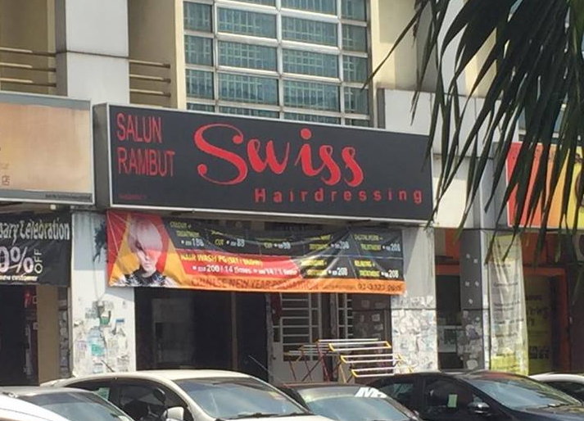
Kelly invested roughly one hundred thousand to open her own hair salon, Swiss. She was interested in this profession and was willing to spend her savings on furnishing and renovation. We were very proud with her contribution and insistence to this interview.

P & L Salon

The hair salon that we decided to interview in Negeri Sembilan goes by the name of P & L Salon. This salon is owned by a man and a woman called James Lee and Apple Peng, who happens to be in a husband and wife relationship. The salon was established since the year 1994. P&L Salon is a home based salon. They had a shop at first, but after the raise of price in rental and model due to the implementation of GST, they planned to do a home base salon and moved half a year ago in order to continue their role as a hairstylist.
The owner, James Lee, took his first step towards the path of hairdressing at the age range between 18 to 20. During the early stage in 1984, James went to Thailand and worked as a hairstylist. He started to gain experiences and skills about hairdressing. After he graduated from high school, he decided not to further his studies. This was because he realized the excitement he has when he deals with hair salon and that his passion had been excavated. When he first met with Apple Peng, they were working in a same hair salon. They discovered lots of knowledge about the industry together. During their time working together, they found many similarities between the both of them. What first start of as mutual liking became mutual loving. Soon, James and Apple had marriage and decided to establish their own hair salon. They had nothing at first, no diploma, nor certificates as their families were poor and unfortunately, they could not get loan for education. They have no education but still had to earn a living. Therefore, they chose to take up hairdressing skills which was initially their hobby, to make profit. However, they had insufficient funds to accomplish that too. Luckily, they managed to raise enough money with the assistance of relatives and friends. They finally established their own hair salon, P&L Salon in 1994. James is the key founder of this hair salon.
It has been approximately 25 years since they set up their hair salon, James & Apple did not expand their business to a franchise. They just need a hair salon for just the two of them and also have a proper job with loving passions. Besides, they didn’t employ people because they have only a small salon and he also said that the pay for a hairdresser is very high. They need to try their best to minimize the costs while maintaining their salon. Both of them had the experience, the skills and techniques of hairdressing that is suitable for the customers. So, they gained the loyalty and trust from their customers which led to an increase in the consistency of their customers. The flow of income increased gradually as time passed. Fashion trends always being mobile. Therefore, sometimes they will traveled overseas to gain more knowledge about arts of hairdressing in order to refine their skills and to satisfy their customers. They always maintain a friendly and clean environment in their hair salon. P&L Salon provides lots of skilled services, such as haircuts, hair washing, hair coloring, hair rebonding and scalp treatment.

His career is his hobby, to make people beautiful on the outside. When their customers are happy with their hairstyles, they would also feel happy within. They feel accomplished after making people satisfied with their skills. P & L Salon is their livelihood and also their achieved target.
Comparative Analysis of the Businesses
Swiss, Klang, Selangor
In Selangor, the businesses are more competitive compared to other states. Selangor is the most populous state which has approximately 5.46 million of people. Therefore, the number of hair salons or barber shops are definitely high in Selangor which will cause a very competitive market. There are approximately 250 to 300 of hair salons in Selangor. Swiss hair salon is located in Klang, Selangor. There are about 15 to 20 of hair salons distributing in that area which are Depelo Hair Salon, Yanly Hair Stylist, Kim Hair Professional Studio, Windz Hair Studio and etc. All these salons are located approximately 5 minutes of walking distances. Therefore, the share of market are extremely big for Swiss.
We have figured out the top three competitors after interviewing with the owner of Swiss, Kelly. The first strong competitor is Windz Hair Studio, which is located at opposite row of Swiss. Windz Hair Studio is one of the most well-known salons in the area. They offer different services such as hair styling, hair perming, hair colouring, make up and other hair services. The equipment they use are mostly imported from other countries. The advanced and high-tech equipments can reduce the damage of the texture of hair as well as cause harm to our scalps. Therefore, for those who really care about their hair would return for their services in order to maintain a healthy glossy hair. Obviously, their prices would be high compared to other salons because of the imported equipments.
The second strong competitor is Depelo Hair Salon, which is just the second shop beside Swiss. Depelo is a stylish salon with modern and elegant interior design which gives the customers a comfy and enjoying surrounding. The soft and relaxing music releases are played throughout the salon, attracting many customers. Most of their customers are young adults because most of their hairdresser are aged similar with the young adults which is between 18 to 30. They are often concerning and exploring the most fashionable hairstyle in every season. Therefore, they could content the demand and expectation of a young adult.

The third strong competitor is Hair Matters. Yanly is located at the opposite of Swiss. Hair Matters attracts crowds of teenagers due to the cheaper prices as compared to Swiss. Besides, the hair salon provides huge promotions that encourage customers to return for their services. To gain high profit, the hair salon also provides free washing and hairstyling services for customers after a haircut.
Swiss, however, remains calm when facing its surrounding competitors. Instead of worrying about the competition, Swiss maintains its focus on its customers. Kelly, the owner feel that the attitude and behavior to a customer is most important in order to maintain the result of business. They will also provide professional suggestion on the types of haircuts they should give a try. Sometimes, they feel pleasant if the customers recommend their salon to their friends and relatives.
The nature of the market of Swiss Hair Salon is perfectly competitive as the number of hair salon in Klang is really high, where competitors compete with each other to attract new potential customers. This market also lacks of monopoly, which means when one business controls the whole market.

P & L Hair Salon

In this contemporary, hair salons have increased in Seremban area which means that P&L hair salon is facing a strong competition in the hair and beauty industry. P&L hair salon is a hairdressing shop that is old-fashioned but they provide good and friendly services. There are a few competitors that are located nearby the area which are Purple House Salon, Jin Jin Unisex Hair & Beauty Salon, One & One Salon, Raymond Hair Salon and A Creative Salon. Among the competitors, the ones that have the most competition are Purple House Salon, Raymond Hair Salon and One & One Salon.
First and foremost, the Purple House Salon is located right opposite street of P&L Salon. This hair salon is quite renowned in the area. It provides all sorts of services which includes hair dyeing, hair styling and hair perming and other kinds of hair services. The employees are friendly as well as the P&L Salon. The equipment that they choose are high-quality but that is also the reason why every treatment is pricey for every customer.
Secondly, this salon is named after his own name, Raymond Hair & Beauty Salon. This salon has beautiful interior design inside the shop itself. It is true that customers are attracted by the modernized design of it as it draws attention. People who visit the place would recommend their friends and relatives to go there because it also provides friendly services. However, the salon sells its products at a much higher price than any other shops.

Thirdly, the third salon is the One & One Salon. This salon is located at two streets away from P&L Salon. It has received popularity because of the extra services that they provide such as pedicure and manicure services. Nowadays, youngsters are more likely to do manicures because it beautifies our fingers and it keeps our fingers in a good state. There is not much shops that includes manicure and pedicure services, but this salon has provided. Customers always come back again and again for hair treatment and also manicure.
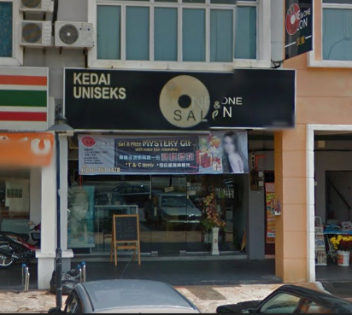

P&L Salon has taken a few strategies to face these competitors. Because of their long-term business in the hair and beauty industry, owners of P&L Salon have gained lots of customers that come back to them every month and year. They use the strategy of communicating with their customers in a friendly way to make their customers feel like they are talking to a friend rather than just a plain employee busy cutting and styling. Next, they have a shop at the start of their business, but, they move their business to their home. Part of the reason is because of the rising tax from the government, however, it seems that it is also part of their strategies. They want to do a home-based hair and beauty business because they think, by having their salon built at home could make their customers feel more nice and comfortable. Another strategy is that the owners will always keep up to date about the latest trend of hairdressing such as Korean style that has been the trend for a whole year.
The overall view is that in order to stay in competition, owners and employees of hair salons need to be aware of what customers need, the haircutting skills and the pricing of hair services. This is to build a good reputation in front of their customers.
The nature of P&L Salon has the potential to be as competitive as the other salons as competitions among competitors is present in the market.

Summary Table
Swiss | Differences | P & L Hair Salon
2010 | Year of salon founded | 1994
Six workers, all of them are  females | Workers | Two workers, who are the owners of this salon
One branches, which is just located behind the first-founded salon | Branches | None
- Local customers, mostly from Klang  - White collars | Main Customers | - Local customers, some are from Kuala Lumpur  - Families
Wide walkway and large waiting space for waiting customers | Space | Spaces are compact
Workers are individually given specific tasks such as hair cutting, hair blowing, hair coloring and etc. | Corporate  Hierarchy | Workers are not given specific task, workers need to provide all services that customers need.
Large variety of haircare products. | Products Variety | Focus on few brands of haircare  products.
Latest music | Music System | Radio music
Facilities are new, clean and are in good condition. | Facilities | Facilities are visually old.
High | Prices | Low
Establish additional branches | Future Plan | None
Shop Lot | Location | Home base salon

Conclusion of comparative analysis
Based on our analysis, Swiss would be the more commercially successful business. It is because the number of customers in Swiss every day are statistically higher than P & L Hair Salon. They have more workers to handle and serve the customers. Swiss can shorten the time by having more workers to do hair washing, hair colouring, hair straightening and hair perming which usually take few hours to accomplish. However, the customers of P & L hair salon have to wait patiently as they have only two workers especially when there are a lot of customers who doing hair straigtening, hair colouring and hair perming which the processes are required a long hour time to finish.
P & L Hair Salon has about 22 years of experiences on hairdressing. The owners have a very skillful and professional handworks compared to Swiss which are mostly very young apprentices. However, the hairstyles they prefer are mostly old-fashioned. They rarely to stay up-to-date with current fashion trends as they have their families to take care. Swiss would be having more advantages as their workers are mostly young adults which are aged between 20 to 30. They can read and know what kind of hairstyle the customer prefer. The modern and high-tech equipment in Swiss also attracts many young adults to come and do different latest hairstyles while P & L only has old and outdated equipment which limited the option for the customers.
Although there are large amount of competitors in Klang, Swiss still manages to improve and maintain their business very well. To retain the customers, a good service is very important because it will affect the first impression of their hair salon. The workers have to keep on improving their skills and handworks in order to reach the expectations of the customers. Therefore, Swiss is considered to be a more commercially successful business compared to P & L Hair Salon.

Recommendation

Like every business has its strong advantage point, every business also has its down point. Those down points became a major setback in pulling down the full potential and capability of the business’s profit. After interviewing the salon owners, knowing their background and also their environment, we come out with some suggestions that can make improvements to their business.

SWISS SALON

The first salon we interviewed was a hair salon named Swiss located in Klang, Selangor. Throughout the interview, we find that there were some things the salon could change to make the salon more approachable. One of the suggestion we gave was to renovate the salon. We saw that the salon is quite old and although it has been renovated before, the floors haven’t been covered up with suitable tiles, just plain cement. Proper tiles should be installed to make the place look brand new and cleaner. Cleanliness is very important as nobody would want to come to a dirty salon. Besides that, we feel that the place is a little bit dim. Proper lightings should be used so that the environment of the salon would look brighter and more lively. That way, more customer would be likely to walk into the salon.

Furthermore, we feel that the salon is lack of things to entertain the waiting customers or other customers. For example, there is only a sofa placed for the waiting customer. That is barely enough when peak season arrived such as Chinese New Year, Deepavali and Hari Raya Aidilfitri. Or, when a mother is straightening her hair and asked her daughter to wait for her at the sofa, her daughter will most probably be bored to death. That’s why I think there should be more entertainment. For starters, they should have a larger waiting area. In that waiting area, there should be reading material that can be read by people of any age like newspaper, storybooks, magazine and more. There could probably be a television for the customer who waits. Moreover, proper music can be played during the hair sessions to ensure the salon is more lively and enjoyed by both waiting customer and occupying customer.

Another recommendation is that there should be more stylist on duty. Although booking services are a good way to manage time, what if there is more customer who wants to book the same time? If you take in a customer, then u must reject another customer’s booking. That means the salon would lose another customer. And that customer might look for other salons and hairstylist to cut, straighten or colour his or her hair. Then, this would cause less customer to book the salon’s time and the customers would then disperse. Therefore, effective measures should be implemented. They should take in more experience hairstylist who knows almost everything about hair, instead of just 6 apprentice who only know how to do the usual cut and wash. Experience hairstylist would also build confidence in customers to choose their salon instead of other salons.

P&L SALON

P&L salon is the second salon that we chose which is located in Seremban. After the visit, we realized that there are also some things about the salon that could be changed. Firstly, since P&L salon is a home-based business, it is located near housing areas. Being in housing areas mean that the salon is only known in that particular housing area. Not many people would know about that salon, especially outsiders. Therefore, we suggest that P&L salon should advertise the salon more. For example, P&L salon can advertise itself through social media such as facebook, twitter and snapchat. They can post information about the salon to raise curiosity of outsiders of its capabilities in this industry. Besides, advertisement can be done through catalogs, magazine and newspaper. For instance, P&L salon can provide promotion through catalogs, magazine and newspaper such as free hair cut or 50% off on rebonding and treatment. This way, customers would be more motivated to try their services and more likely to know about it.

Moreover, P&L salon should hire more people to work. This is because insufficient staff is one of the reasons why less customer wants to come to this salon as most people do not like to wait, especially if there is a long line in front of you. Some people would rather choose to go to another salon and pay a little more so that they do not need to wait so long. Therefore, P&L Salon should try looking for more staff. We know that they didn’t hire anyone because they want to minimize cost and because the cost of hiring a hairstylist is expensive. However, they should think of this in another point of view. If hiring more staff means more customer, that means that we will earn more profit.

Blibiography
Lewis, W. (2002). Hair Affair. Quadrille Publishing Limited.
Hatton, P. (1990). Foundation Hairdressing. Blackwell Scientific Publications.
Tezak, E. (2012). Successful Salon & Spa Management. Erin O'Connor.
Moren, S. (2004). The Ultimate Guide To Spa & Salon Ownership.
Brondt, C. (2009). Read Research and Write.
Marsh, C., Guth, D., & Short, B. (2012). Strategic Writing.
Appendices

We were able to interview two salons after a couple of rejection of other business. We tried many other businesses but failed to interview them. This two hair saloon’s bosses are friends of member in the group that’s why we were able to get them to interview for our English project. Here are some photos and interview Q&A that we took in both shops:
Swiss, Klang, Selangor
Location: 12A, Lorong Batu Nilam 21B, Bandar Bukit Tinggi 2, 41200 Klang Selangor, Malaysia.

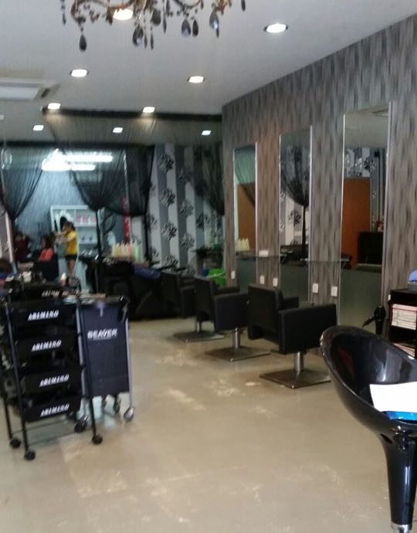
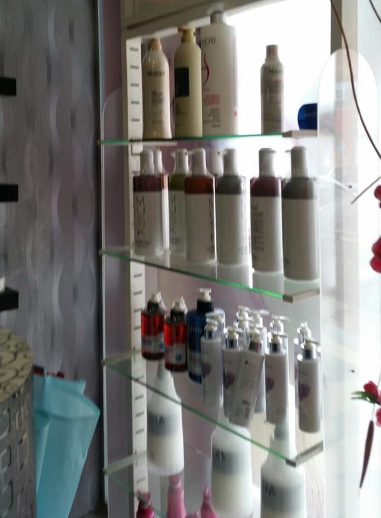

Interior of the salon

A photo of a member interview the owner of the salon

Products that the salon use

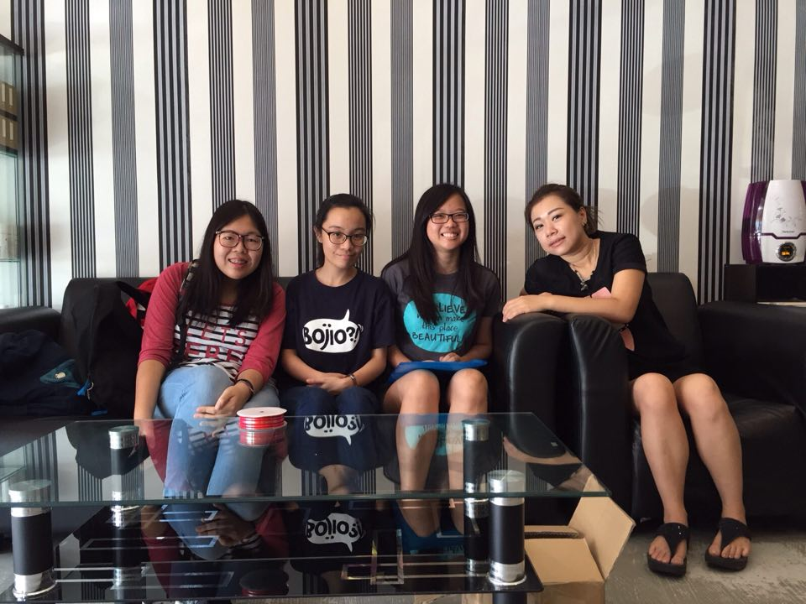

A group photo with the owner of Swiss, Kelly
Interview Questions (Swiss Hair Salon)
- Can you introduce yourself?
I am Kelly.
- What is your current position in this company?
The owner of this hair salon, Swiss.
- How much do you like your job?
I enjoy working as a hairstylist right after graduation.
- How long have you been in this industry?
About 10 years
- Why are you motivated to work in this salon?
Is not about saying what motivate me because since young she already started to do this industry.
- When was the salon business founded?
2010
- Who are the key founders of this salon?
I founded this salon.
- Who are your usual customers? Where do they usually come from?
Usually klang people. They come here to do their hair. Their age is like every age group. Usually the whole family will come to one salon.
- How many customers you have for each day?
Roughly 20 people.
- How many employees are there in this salon?
6 apprentices
- How many facilities approximately are there in this salon?
We have 6 sits and 2 for washing hair.
- Is there any other branch or franchise of this hair salon?
There is one behind of this shop.

P&L Hair Salon, Seremban, Negeri Sembilan

Location:
1423, Jalan Sentul 1, Taman Ujong, 70100 Seremban, Negeri Sembilan.

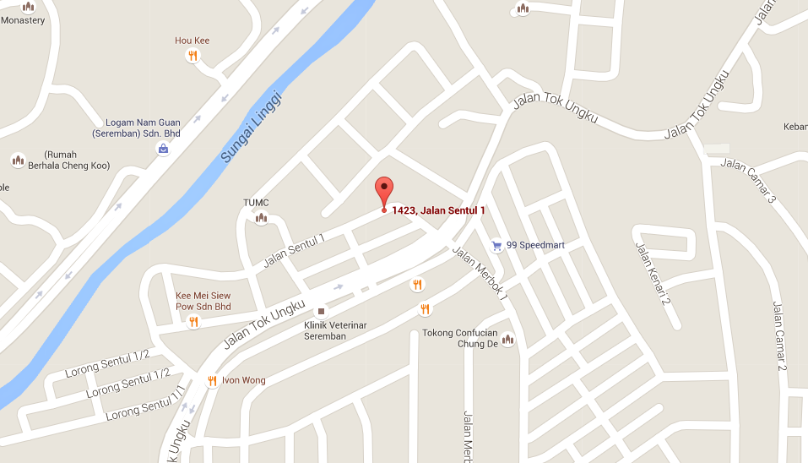

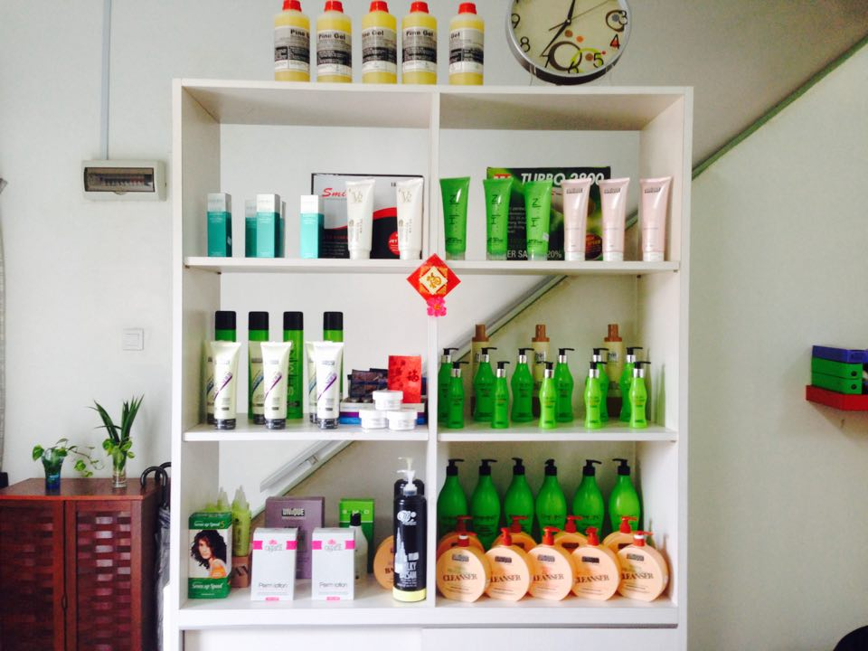
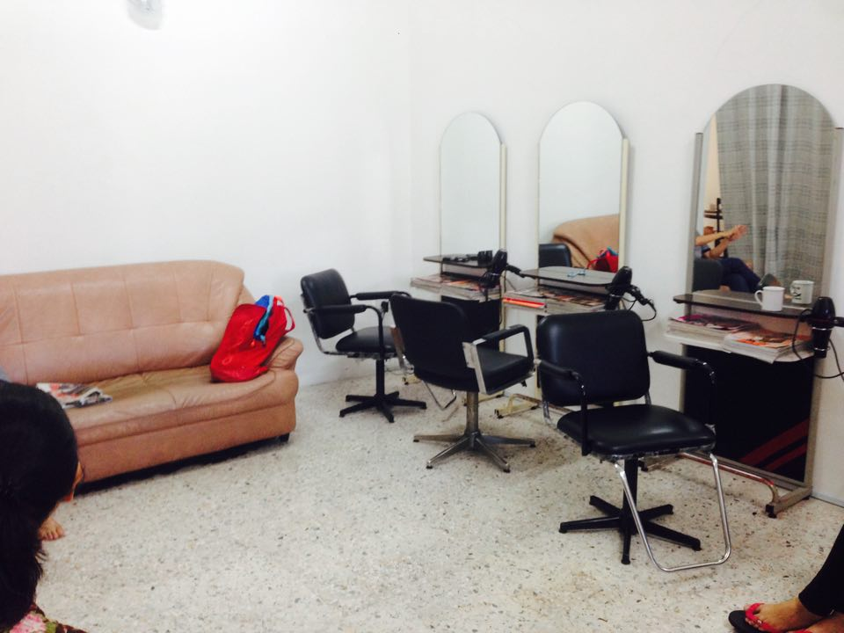

Interior of the salon
3 seats for hairdressing
Products that the salon use
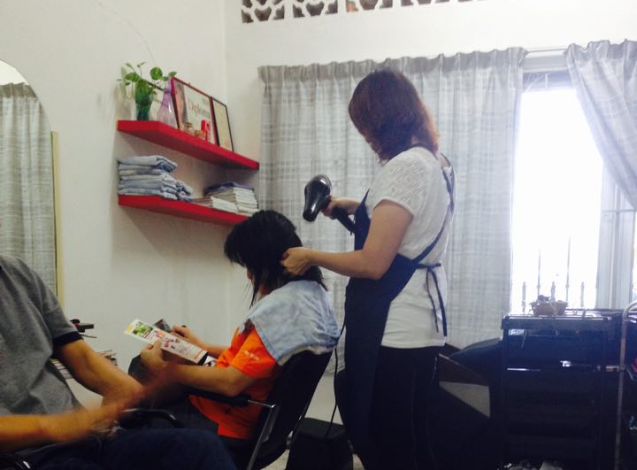

The regular costuer and the owner
Interview session
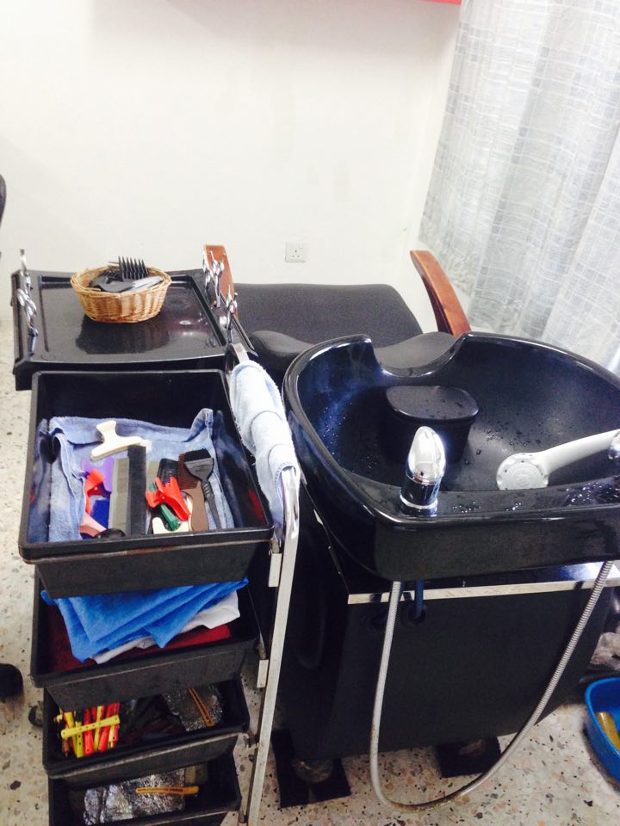
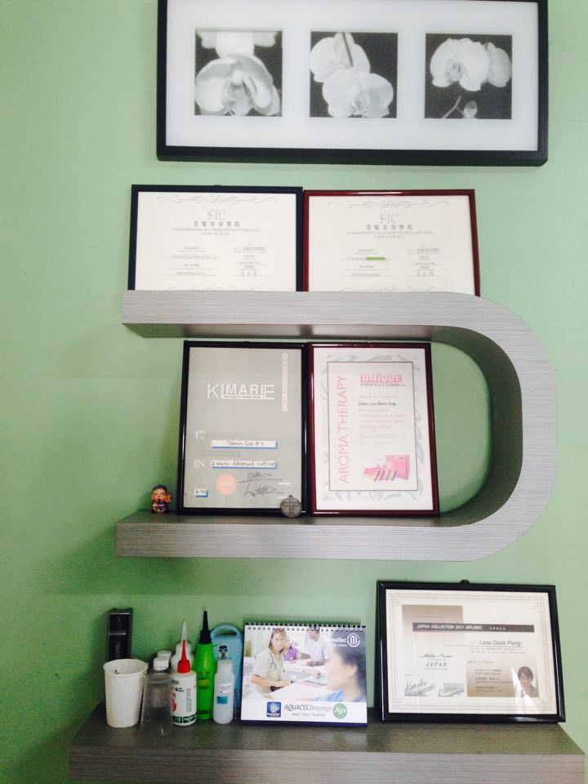

Certificates
Certifications
The one and only washing place
Interview Question (P&L Hair Salon)
- Can you introduce yourself?
I am James Lee and this is my wife, Apple Peng
- What is your current position in this salon?
We are the owners of this salon. We have no workers. We act as director, manager and also cleaner.
- How much do you like your job?
It is a tiring job but I enjoyed it very much. I like to make people beautiful. Customer happy then we also happy. We feel accomplished after making people satisfied with our skills.
- How long have you been in this industry?
It is about 20 over years, nearly 30 years.
- Why are you motivated to work in this line?
We had nothing last time, no diploma, not much college. Our families are poor and we could not get loan for education, so we learned hairdressing to earn a living.
- When was the business founded?
1994.
- Who are the key founders of this business?
Both of us are the key founders of this hair salon .
- Can you provide us a brief history of your business and its most recent developments?
I met my wife in Seremban. Both of us were not from Seremban so we planned to open a salon shop to earn a living. During the early stage in 1984, I went to Thailand and worked as a hair stylist. From there, I gained experiences and opened a shop in Seremban. We had a shop at first, but after the raise of price in rental and model ( because of gst), we planned to do a home base salon( move half a year ago), to continue our role as a hairstylist to their regular costumer.
- What prompted you to start this business?
To earn a living, we had no education so we chose to take up hairdressing skills to make profit.

- Who are your usual customers? Where do they usually come from? (Are they locals or foreign customers?
Mostly Chinese. The people who come in various age group. ( usually one whole family goes to the same salon). They come at least one month time, some they do treatment. Costumers recommend friends to come so we also have people from kl come over here. Or even overseas, they come back and do their hair.
- How many customers you have for each day?
Roughly 10 costumers. Weekend usually has more people than weekdays.
- How many employees are there in this hair salon?
We have no workers, because we are a small salon and to minimize the cost. The pay for a hairdresser is very high.
- How many facilities approximately are there in this salon?
We have 4 sits in their home base salon and one to wash hair.
- Is there any other branch or franchise of this hair salon?
No.

Meeting Minutes: 1 hour
Date: 30 December
Time: 7pm ( over dinner)
Venue: Tian Chu
Attendance: Tan Vin Nie, Vivian Tay Huey Shuen, Ho Zi Yan, Yong Ai Yi, Yeoh Sin Yuen, Wong Cho Mun, Lim Xiu Qing
No | Activity | Remark
1 | Study of the brief | We go through the brief on the task
2 | Business selection | We choose on (siew pau) bakery shop at first. We picked two places which is Seremban and Klang valley.
3 | Appointment | We called up the shop but got rejected.

Date: 5th Jan
Time: 12.30pm (over lunch)
Venue: Backofen
Attendance: Tan Vin Nie, Vivian Tay Huey Shuen, Ho Zi Yan, Yong Ai Yi, Yeoh Sin Yuen, Wong Cho Mun, Lim Xiu Qing
No | Activity | Remarks
1 | Business reselection | Optic shop. A member of ours has contact within Klang valley
2 | Appointment | We called up optic shop in Seremban and again, got rejected by many shops
3 | Business reselection | A member has some contacts within Klang and Seremban
4 | Appointment | Klang – appointment made on Monday  Seremban – appointment made on Wednesday

Reference
The Rise of Hair Salons Through the Ages. (2014, June 23). Retrieved from http://www.curioushistory.com/the-rise-of-hair-salons-through-the-ages
Hairstyling Tool. (n.d.). Retrieved February 28, 2009, from https://en.wikipedia.org/wiki/Hairstyling_tool
The Shaving Historical Timeline. (n.d.). Retrieved from http://haircuttingstories.net/Story/SingleStory/55b83e96e8f05328db60702d
Schmidt, J. (n.d.). The History of Hairdressing. Retrieved from http://www.datehookup.com/singles-content-looking-your-best-the-history-of-hairdressing.htm
Small Business Interview Questions. (n.d.). Retrieved from http://condor.depaul.edu/pkemp/businterviewq.htm
The qualities, knowledge, and skills it takes to be a successful hairdresser. (n.d.). Retrieved from http://www.hairdressersinsurance.org.uk/hairdresser-skills.html
Advanced cutting techniques. (n.d.). Retrieved from http://hairdressing.ac.uk/lessons/howtocuthair/advancedcuttingtechniques.html
6 Smart Hair Styling Tools. (n.d.). Retrieved from http://www.realsimple.com/beauty-fashion/hair/hair-styling-tools
MHA Home. (n.d.). Retrieved from http://www.mha.org.my/home/
The 21 Best Short Hairstyles and Haircuts To Try Now. (n.d.). Retrieved from http://www.marieclaire.com/beauty/hair/g409/short-hair-how-to-hairstyles/

